Name:

Period:



**SCAVENGER HUNT: THE CONSTITUTION OF THE UNITED STATES OF AMERICA**

*The U.S. Constitution was approved by the Constitutional Congress and sent to the states for ratification in September 1787. What do you know about the Constitution?*

**Directions**: *Explore the Constitution online by going to* [*https://constitutioncenter.org/interactive-constitution/full-text*](https://constitutioncenter.org/interactive-constitution/full-text)*. Then write the missing word or words in the blanks below.*

|  |  |
| --- | --- |
| 1. What branch of government is described in Article I? |  |
| 2. How often are Representatives to be elected? |  |
| 3. How old must a Representative be to be elected? |  |
| 4. How long is the term for a senator? |  |
| 5. How old does someone have to be to be a senator? |  |
| 6. Who is the president of the Senate? |  |
| 7. When may the president of the Senate vote? |  |
| 8. Which legislative body has the power of impeachment? |  |
| 9. Which body has the power to try an impeached official? |  |
| 10. The Constitution lists the powers of Congress. List two of them. |  |
| 11. When may the writ of *habeas corpus* be suspended? |  |
| 12. What branch of government is described in Article II? |  |
| 13. How old does someone have to be to be elected president? |  |
| 14. What is the name given to the body of people who elects the President? |  |
| 15. Name two powers of the President. |  |
| 16. What branch of government is described in Article III? |  |
| 17. What is the term of office for Supreme Court justices? |  |
| 18. What fraction of the houses of Congress is necessary to approve a proposed amendment? |  |
| 19. What fraction of the states must approve a proposed amendment for it to be ratified? |  |
| 20. What is the “supreme law of the land”? |  |
| 21. What are the first ten amendments to the Constitution called? |  |
| 22. Which amendment extended the vote to 18 year olds? |  |
| 23. Which amendment outlaws “cruel and unusual punishments?” |  |
| 24. Which amendment ended slavery? |  |
| 25. Which amendment said that states couldn’t prevent people from voting based on their race? |  |
| 26. Name the five basic civil liberties guaranteed in the First Amendment. |  |
| 27. Which amendment said the states could not deny a person citizenship/equal protection of the laws? |  |
| 28. Which amendment gave women the right to vote and in what year was it passed? |  |
| 29. Which amendment requires a warrant to search someone's property? |  |
| 30. Which amendment implies that all powers not given to the federal government are reserved to the states? |  |

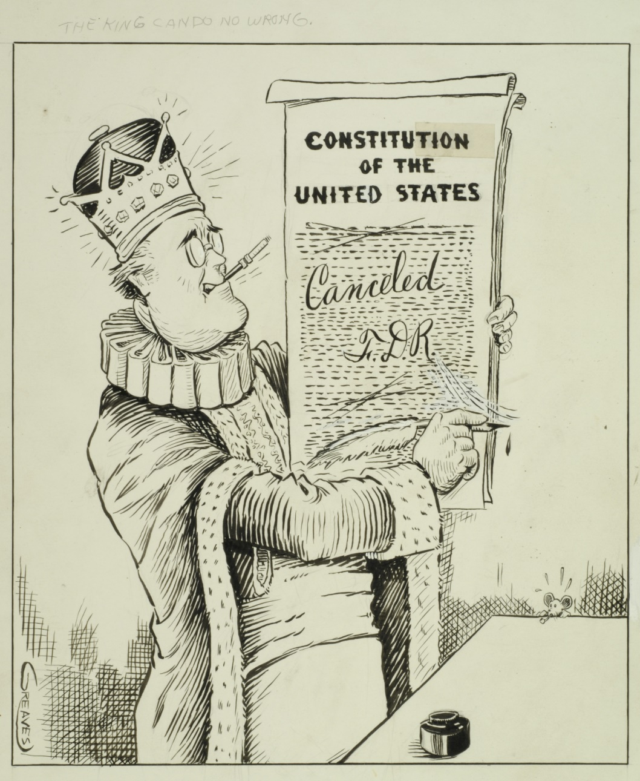

31) What do you see in this political cartoon? Describe at least three details.

32) Do you think the creators of this political cartoon supported or opposed President Franklin D. Roosevelt? How can you tell?

33) What do you think that the cartoon means?